**1.Spring-Data-JPA Handson**

**1.Spring Data JPA - Quick Example**

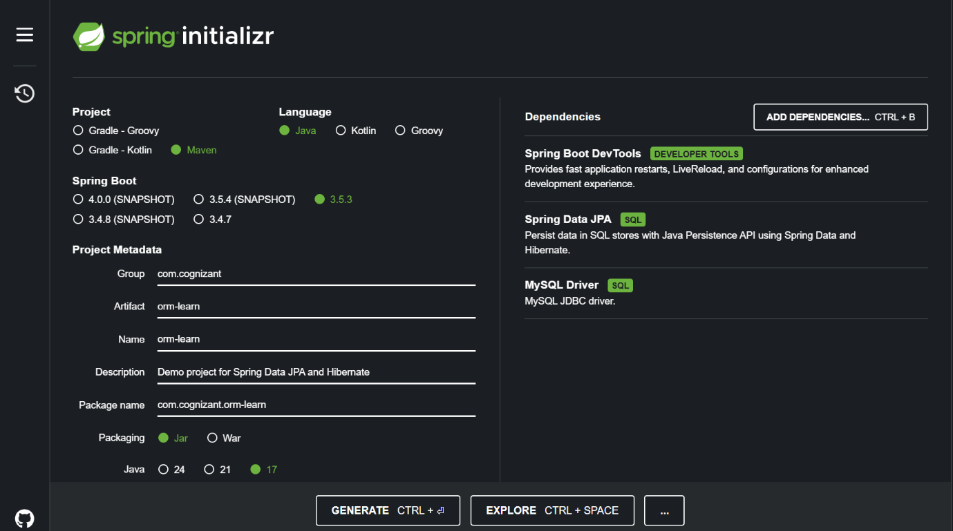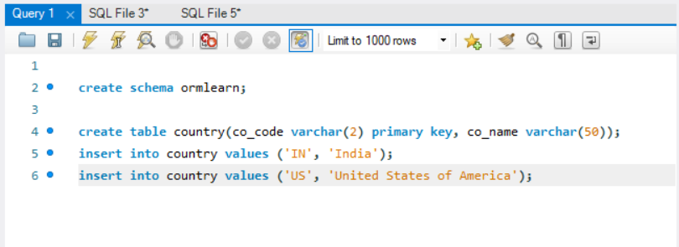

File Name: application.properties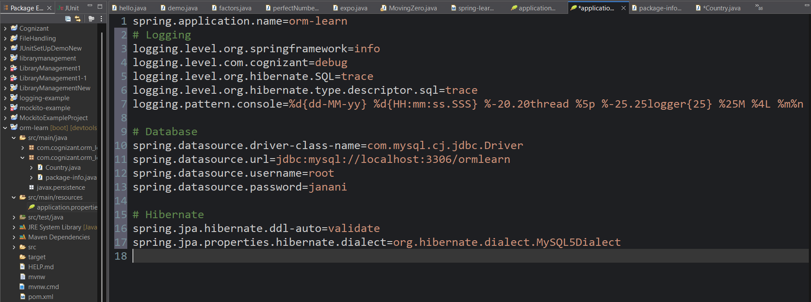

File Name:OrmLearnApplication.java

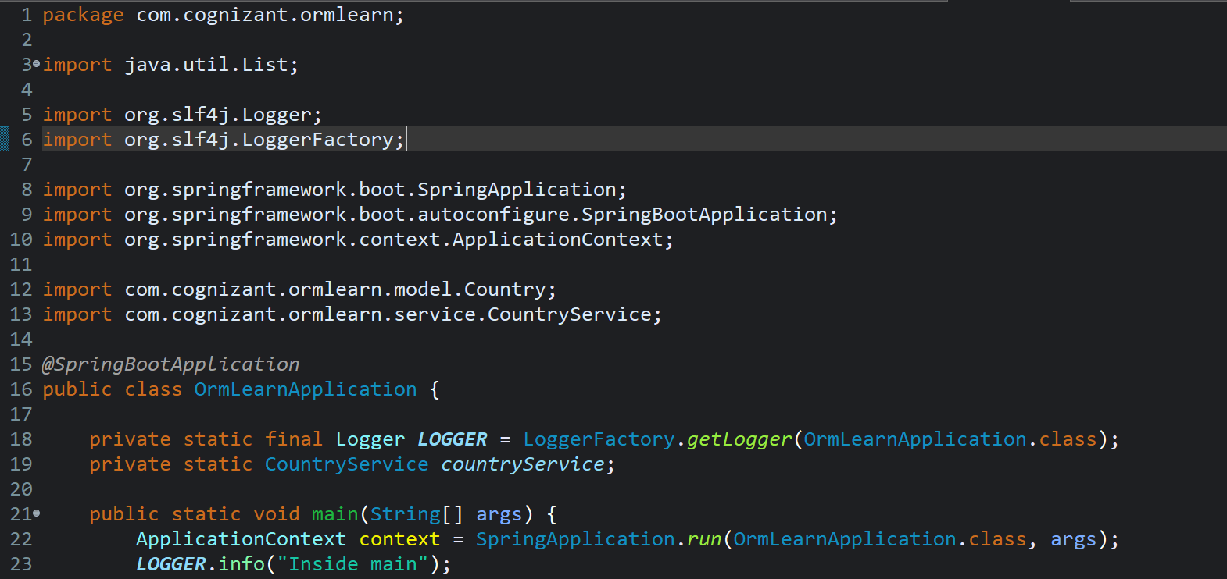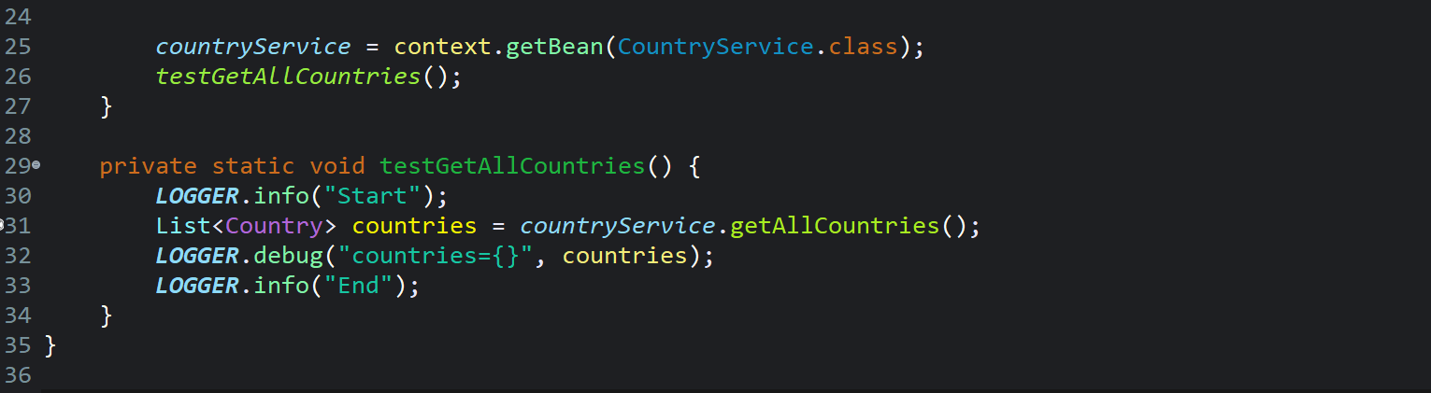File Name: Country.java

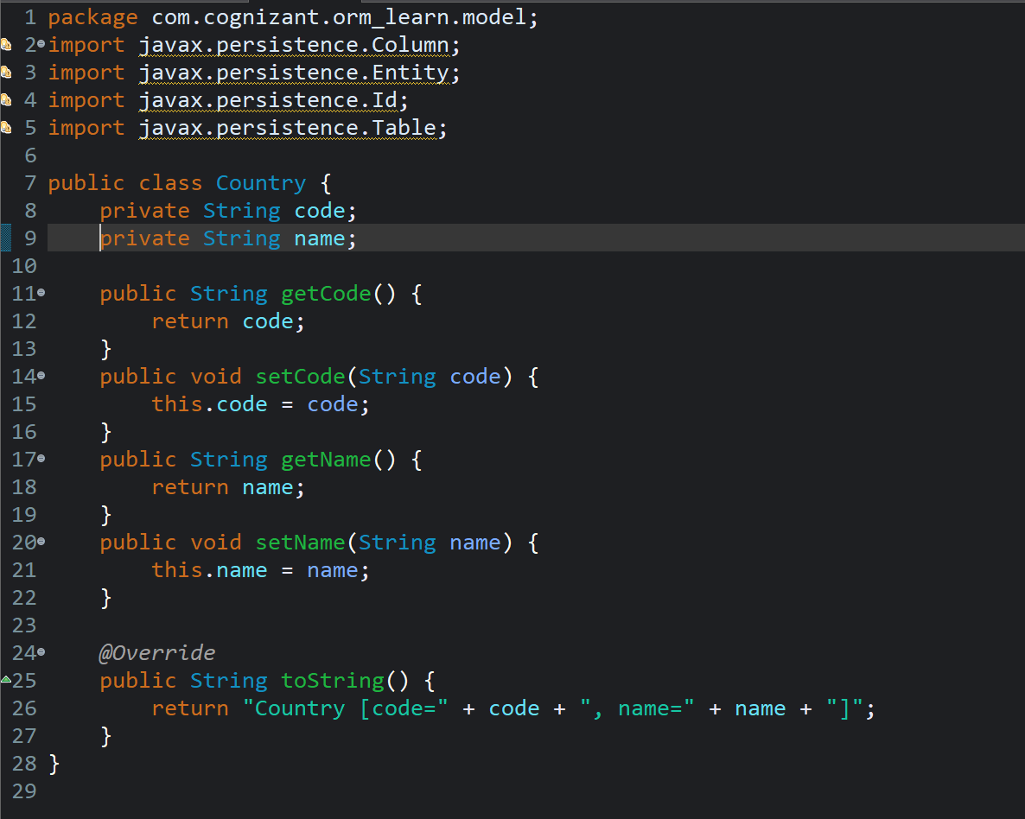

File name: CountryRepository.java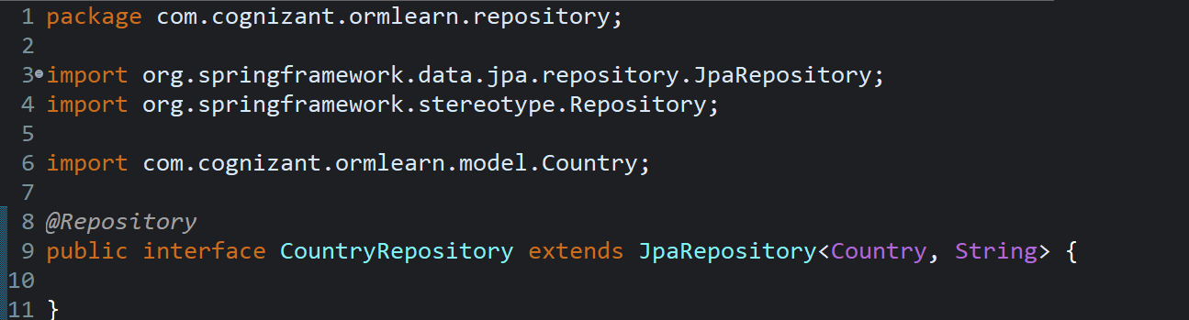

File name:CountryService.java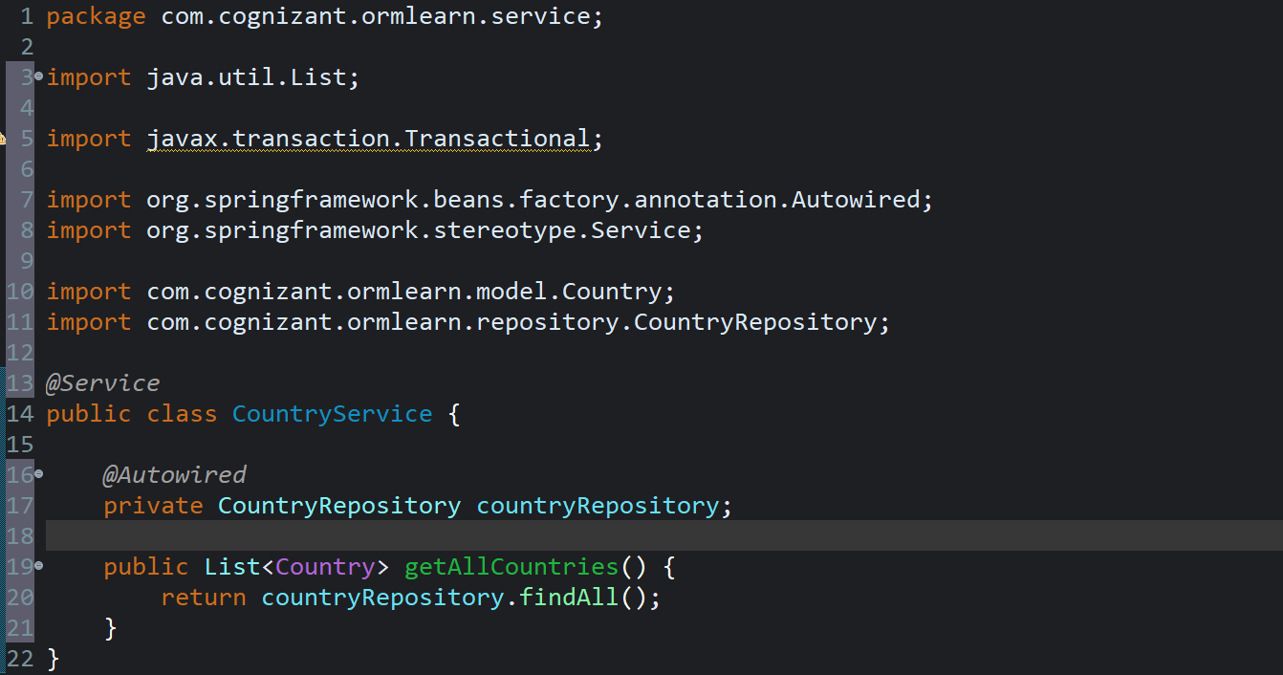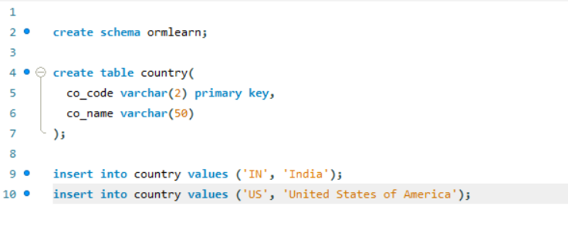

**2.Difference between JPA, Hibernate and Spring Data JPA**

File name:Employee.java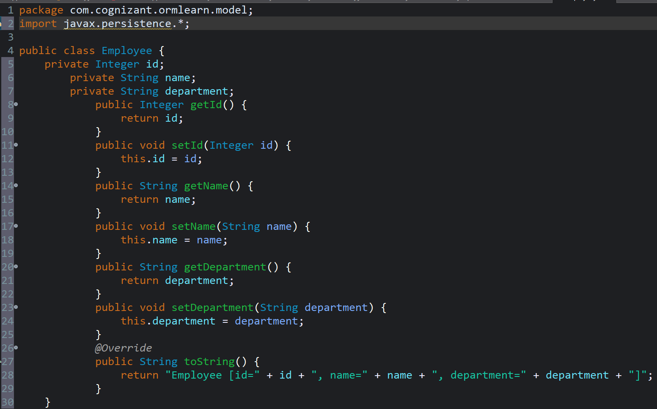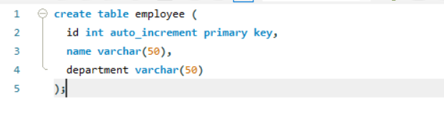File name:EmployeeDao.java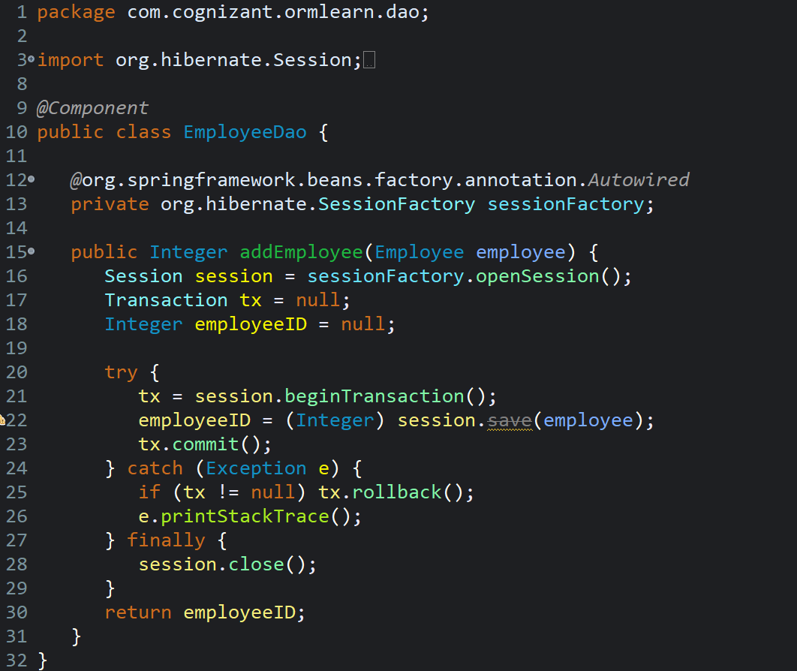

File name:EmployeeRepository.java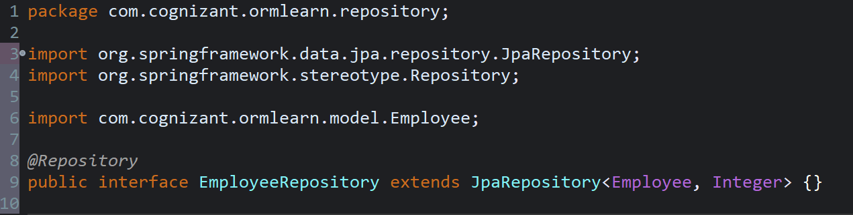

File name:EmployeeService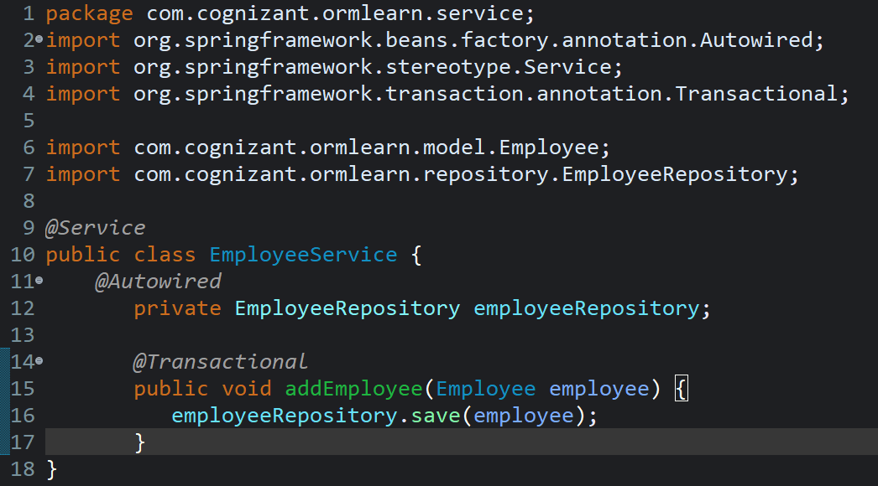

File name:OrmLearnApplication.java